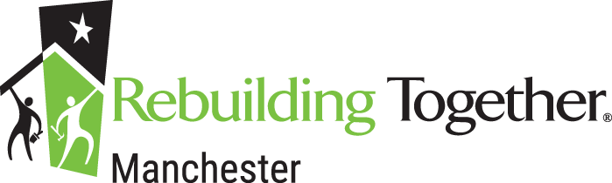
Application Checklist for Roofing Rehabilitation Program 2026
Basic Criteria
To be considered for our programs, homeowners must meet the following criteria:
- You must be the legal property owner and the home must be located in Manchester, CT
- You must currently have lived in the home for 5 years and plan to remain living in the home for at least the next 5 years
- You must be low-income and reasonably unable to complete the work on your own
- You must be up to date on your taxes, mortgage, and sewer and water bill
- Priority is given to those with an active leak and must be able to show and have verified with contactor and program administrator the active leak in the house

- Application Part 1

- Application Part 2

- Income information

  - Documentation for all income sources – Everyone who lives in the home must supply income verification and documents. Sources of income may include 3 most recent paystubs, social security, pension, unemployment etc.
  - Most recent filed IRS Form 1040

- Copy of recent checking and savings account statements-3 months

- Copy of your most recent mortgage statement showing $0 past due balance

- Submit all application materials to:
  - Rebuilding Together of Manchester
448 Tolland Turnpike
Manchester, CT 06042

