Town of Manchester
41 Center Street
Manchester, CT 06045
860-647-5235
FOR IMMEDIATE RELEASE

Town of Manchester Celebrates Groundbreaking of Silk City Commons,
Signaling Next Chapter for Broad Street Parkade Redevelopment

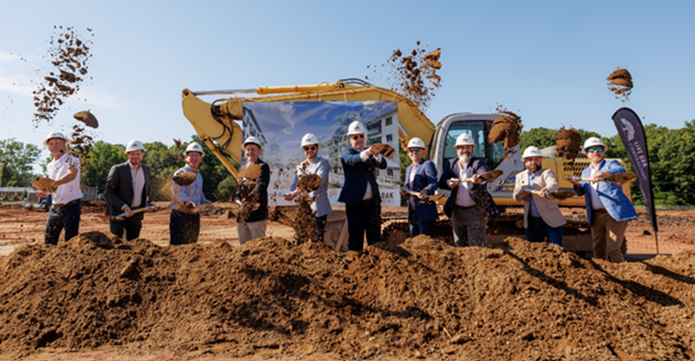

Manchester, CT - Local officials, project partners, and community leaders gathered recently to celebrate the official groundbreaking of Silk City Commons, marking a transformative milestone for the Broad Street Parkade redevelopment area. The new 232-unit multifamily community represents a major step forward in turning five former commercial properties into a vibrant, highly connected, and walkable neighborhood destination.

Developed by Anthony Properties in close partnership with the Town of Manchester, Silk City Commons is designed to blend modern apartment living with unparalleled access to local recreation and culture. The community will feature a robust suite of amenities, including a resort-style pool, pickleball courts, a dedicated dog park, and welcoming indoor and outdoor gathering spaces for residents.

Strategically situated in the heart of Manchester, the development boasts proximity to the Bigelow Brook Greenway, Center Springs Park, the Cheney Historic District, and the shops and dining of Downtown Manchester, offering a true "live, work, play" lifestyle.

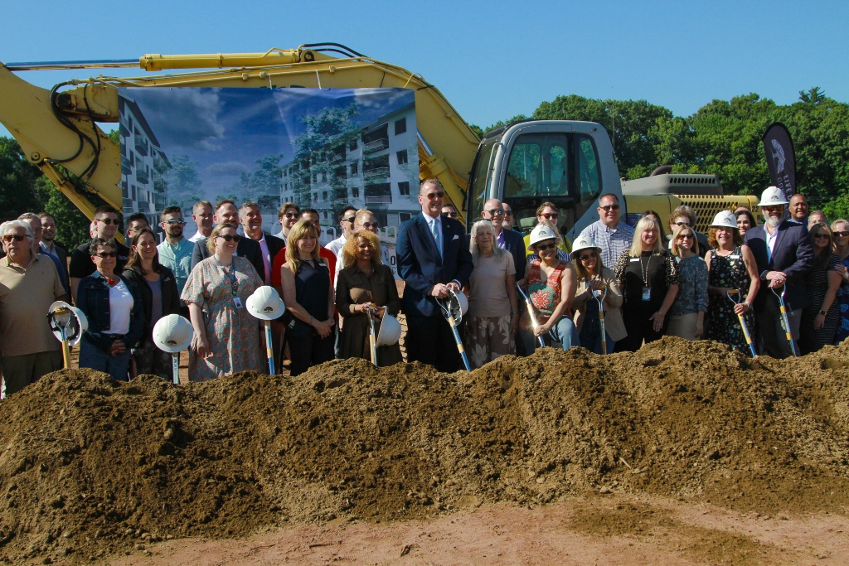

"This groundbreaking is a monumental win for the Town of Manchester," said Manchester Mayor Jay Moran. "For years, our community has envisioned a modern, walkable neighborhood that breathes new life into the historic Broad Street corridor. Silk City Commons delivers exactly that—bringing high-quality housing, economic energy, and beautiful public amenities that connect seamlessly with our downtown and trail systems."

The groundbreaking ceremony featured remarks from municipal leaders and project partners, all highlighting the collaborative effort required to launch this major revitalization project.

"Transforming this site from an underutilized commercial space into a thriving neighborhood destination has been a long-term priority for our community," said Aaron Wlochowski, Chair of the Manchester Redevelopment Authority. "Partnering with Anthony Properties allows us to realize the full potential of the Parkade area. Silk City Commons will not only provide exceptional modern spaces for future residents, but it also establishes a strong foundation for the continued growth and economic vitality of Manchester."

"Redevelopment of this scale does not happen on its own—it is the result of years of shared vision, persistence, and intentional collaboration," said Gary Anderson, Director of Planning and Economic Development for the Town of Manchester. "A massive Thank You goes out to the entire Manchester community for your feedback and patience, to our dedicated Redevelopment Agency members, and to our elected officials and Town staff, past and present, who worked on crafting the policies and partnerships that made today possible. This is a proud moment for everyone who has had a hand in shaping this important piece of Manchester’s future.” Construction on Silk City Commons is officially underway, with project partners looking forward to steady progress and the eventual welcoming of its first residents.

###
Contact: Gary Anderson
ganderson@manchesterct.gov
860-647-3043

