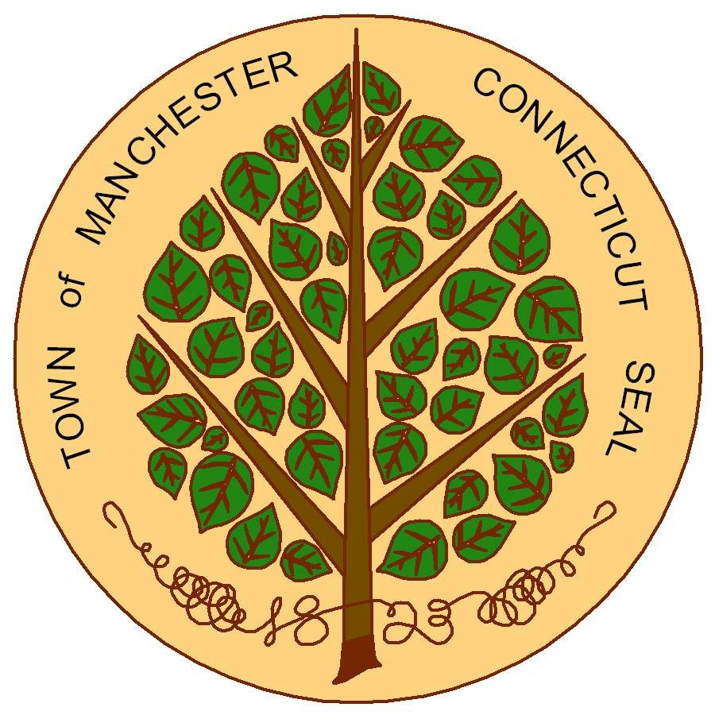
TOWN OF MANCHESTER
COMMUNITY DEVELOPMENT BLOCK GRANT (CDBG) PROGRAM
CD034 PROGRAM YEAR: OCTOBER 1, 2024 – SEPTEMBER 30, 2025
FUNDING APPLICATION

Eligibility for Projects/Activities:
For an application to be considered for funding, the following qualifications must be met:
- The proposed activity must meet a national objective of the CDBG Program: benefit low- and moderate-income persons, aid in the prevention or elimination of slums or blight, or meet an urgent need;
- The proposed activity must be listed as an “eligible” activity in the CDBG regulations; and
- The proposed activity must address a priority need as outlined in Manchester’s 2020-2024 Consolidated Plan.
Please Note:
- If you are applying for more than one project, please submit a separate application for each and include a prioritized list of applications submitted.
- Funds will not be available until the program year begins October 1, 2024.
- The Town may not be able to fund all applicants or fund an applicant’s full requested amount.
- Programs may serve residents of any town, however CDBG funds can only be used to serve Manchester residents.
- All funding applicants must have a Unique Entity ID (UEI) number and active SAM registration.
https://sam.gov/content/entity-registration
- Funded sub-recipients will be required to collect and submit beneficiary race, ethnicity and income data.
Submission Requirements:
All applications must be completed in full and include all applicable documents listed in Section III: Checklist of Required Documents.
Questions regarding the application should be directed to:
Heather Guerette
Community Development Program Manager
P.O. Box 191
Manchester, CT 06045-0191
Phone: (860) 647-3106
Email: hguerette@manchesterct.gov

* All applications must be received by 4:30 p.m. on Thursday, March 28, 2024. *

TOWN OF MANCHESTER
COMMUNITY DEVELOPMENT BLOCK GRANT PROGRAM
PROJECT APPLICATION 2024-2025 PROGRAM YEAR
APPLICATION DUE DATE: March 28, 2024 at 4:30pm

- GENERAL PROJECT INFORMATION:
Proposed Project/Activity Name:
Amount of CDBG Funds Requested:
Name of Organization or Town Department:
Applicant Mailing Address: |  |  | Street
 |  |  | City ST Zip
President/Executive Director/ Department Head Contact Information:
Project Location Address: |  |  | Street
 |  |  | City ST Zip
Name and Title of Primary Contact for Grant Application and Project:
Phone: |  |  | E-mail:
Unique Entity ID (UEI) No. |  | Does your organization have a current System for Award Management (SAM) registration? |  |  | Yes ☐ No ☐  Expires: _ _____
Note: All recipients of federal funds are required to have a UEI number and active registration in the SAM database. Information on how to register (or to make sure your registration is current) is available here: https://sam.gov/content/entity-registration
Your organization must have an active SAM registration to be considered for funding.

- APPLICANT DESCRIPTION:
☐ | Town of Manchester Department
☐ | Nonprofit Organization
☐ | Other Government Agency
Provide a brief description of your organization or department including your mission, services provided, and clientele served. Please indicate whether your organization/department has experience carrying out a federally funded project/activity.
Unlimited Space Available

- CHECKLIST OF REQUIRED DOCUMENTS:
Note: This completed checklist must be turned in with the application.

The documents listed below are required of nonprofits applying for CDBG Public Service funds:

☐ Proof of current non-profit tax status (prove exempt under IRS Code 501(c)(3))
☐ A copy of most current audited Financial Statements
☐ List of current Board members
The following documents are required from all applicants:

☐ Complete project budget showing revenues and expenditures (Form A or similar)
☐ Rehabilitation and construction projects must include a contractor/architect/engineer estimate.
☐ If submitting multiple requests, a prioritized list of projects/activities must be included.

- CERTIFICATION:
“I certify that I have reviewed this application and, to the best of my knowledge and belief, the information provided in this application is true.”

Name & Title Date

- NATIONAL OBJECTIVE:
All CDBG funded projects must meet one of the following national CDBG objectives:
☐ | Benefits a low/moderate income area. (See qualifying area map at end of application)  Activity meets needs of low/moderate-income (LMI) persons residing in an area where at least 51% of residents are LMI. Note: An Area Benefit activity is available to all persons in the neighborhood regardless of income. However, the area where the activity is located must qualify as an LMI neighborhood.
☐ | Benefits a low/moderate clientele. (See low/moderate income limits chart below)  Activity benefits a specific group of people who qualify as low/moderate income (LMI) persons. The activity must meet one (1) of the criteria below. If your proposed project/activity qualifies under one of the subcategories, check the applicable box:  ☐ Project/activity maintains client records on income and family size documenting that such persons qualify as LMI.  ☐ Project/activity has income eligibility requirements that limit the activity exclusively to LMI persons.  ☐ Project/activity is of such a nature and location that it may be concluded the clientele are primarily LMI persons.  ☐ Project/activity clientele are presumed (by HUD) to be principally LMI persons  (i.e. homeless, battered spouses, severely handicapped adults, elderly persons)
☐ | Aids in the prevention or elimination of slums or blight.
☐ | Meets an Urgent Need (as defined in 24 CFR 570.208(c))  Recipient must certify the activity is designed to alleviate existing conditions which pose a serious and immediate threat to the health and welfare of the community which are of recent origin or recently became urgent, that the recipient is unable to finance the activity on its own, and that other sources of funds are not available. Note: at least 70% of a community’s funds must be used to meet a low/moderate income objective (above).
Low- and Moderate-Income Guidelines: At least 51% of the funded activity’s participants or beneficiaries must meet HUD’s low/moderate-income guidelines for Manchester. Current income guidelines/limits by number of persons per household are as follows:
Income Category | 1P HH | 2P HH | 3P HH | 4P HH | 5P HH | 6P HH | 7P HH | 8P HH
Low-Income (80%) | $66,150 | $75,600 | $85,050 | $94,500 | $102,100 | $109,650 | $117,200 | $124,750
Effective June 2023
For Projects That Benefit AREAS
- If your project would serve a low/moderate income area (i.e. capital or physical improvements) describe the location of the project or the area to be served.
* A map can be attached to the application to provide more detail about project location. *
Unlimited Space Available
For Projects That Benefit PERSONS
- Provide information that demonstrates your project or program will benefit a majority (51%) low/moderate income persons, as required for CDBG funding.
Unlimited Space Available
- Describe how you will collect and document the income of your clientele to ensure at least 51% of beneficiaries will be low/moderate income. Please also indicate how you will document the race/ethnicity of all program participants, as well as the number of female-headed households, in accordance with HUD’s reporting requirements. (Sample data collection forms are attached for public service and housing rehabilitation, along with information on the race and ethnicity categories.)
Unlimited Space Available
For Projects That Prevent/Eliminate Slum or Blight
- Please describe the blighted area/site and how your project aligns with this national objective.
Unlimited Space Available
For Projects That Meet an Urgent Need
- Please describe the urgent need that will be met and how your project will alleviate the problem.
Unlimited Space Available

- PROJECT DESCRIPTION:
Please provide the following information:
- General Project Information
  - Describe the project or activity for which funds are requested and the proposed use of CDBG funds:
Unlimited Space Available
  - List of locations where activity will be provided:
Unlimited Space Available
  - List of staff positions that will carry out the activity:
Unlimited Space Available
- Outcomes and Persons Served:
  - The number of unduplicated Manchester residents (individuals or households) expected to be served:
Unlimited Space Available
  - Of those served, the number of unduplicated individuals/households who will be of low/moderate income:
Unlimited Space Available
  - The expected outcome of the project or activity:
Unlimited Space Available
- Project Timeline:
  - Over what time period will the project or activity be offered?
Unlimited Space Available
  - How long will it take for funds to be spent:
*Please note: public service projects must spend all grant funds received during the designated program year (10/1-9/30).
Unlimited Space Available
- What measurable outcomes will be tracked? How will you measure program outcomes?
Unlimited Space Available

- CONFLICT OF INTEREST:
Are you aware of any potential conflict of interest between any employee working on this project or activity or Board member representing your agency, and any employee, official, or agent of the Town of Manchester engaged in the award or administration of Community Development Block Grant funds?

An example of a potential conflict of interest is a person employed by your agency or on the Board of Directors of your agency who is related to or has a relationship with a member of the Board of Directors, the Town Manager, or a member of the Town’s Planning & Economic Development Department.

☐ NO ☐ YES Please explain:
- BUDGET:
- General Budget Information
Please provide a complete annual budget for the project/activity for which you are requesting CDBG funds.
FORM A

In Column A, list items for which you anticipate the need for CDBG funds.
In Column B, provide the calculation determining estimated cost of the line item.
In Column C, provide the requested amount of CDBG funds.
Other formats may be used if the same relevant information is provided.

A. Budget Item | B. Calculation | C. CDBG  Request
PERSONNEL
Salaried Positions – Job  Titles | Provide rate of pay (hours/salary) & % of time spent on project
Salaries Total
Fringe benefits
PERSONNEL TOTAL | Total of Personnel & Fringe  Benefits
OPERATING COSTS | Provide description/calculation for each estimated line item
Rent/Lease
Utilities
Telephone
Supplies
Insurance
Printing
Other
Other
TOTAL OPERATING
BUDGET TOTAL

- Additional Funding Sources
Describe plans to use other funds to support the proposed project. In this section, describe only funds secured for this project. Provide the source of funds and amounts.

Source of Funds | Amount of Funds | Name of Grant
Federal Government
Federal Government
State Government
State Government
Local Government
Local Government
Private Funds
Other

